ABE 301 Final Project Report

MODELING CHANGE OF CONCENTRATION OF MOMETASONE FUROATE DIFFUSING INTO THE DERMIS LEVEL OF THE SKIN

Richard Chu

Agricultural & Biological Engineering

West Lafayette, IN 47906

May 1, 2017

**TABLE OF CONTENTS**

*Project Objective Statement………………………………………………………………………………* 3

*Background of Information ………………………………………………………………………….....* 3-4

*Final Iteration……………………………………………………………………………………………*5-10

*Nomenclature……………………………………………………………………………………...*10

*Computational Program………………………………………………………………………………*13-13

*Model Analysis/Final Conclusions …………………………………………………………………* 14-15

*Appendix………………………………………………………………………………………………...*16-32

*Iteration 1………………………………………………………………………………………*16-18

*Iteration 2………………………………………………………………………………………19-20*

*Iteration 3………………………………………………………………………………………21-22*

*Iteration 4………………………………………………………………………………………23-25*

*Iteration 5………………………………………………………………………………………26-28*

*Iteration 6………………………………………………………………………………………29-30*

*Iteration 7………………………………………………………………………………………31-32*

*Literature Cited………………………………………………………………………………………….....*33

**PROJECT OBJECTIVE STATEMENT**

The objective of this project was to create a numerical model that outputs the change in concentration of Mometasone Furoate (MF) in the papillary layer of the Dermis as a function of time as well as axial position after initial application of MF cream to the Stratum Corneum.

**BACKGROUND INFORMATION**

**Eczema:**

Eczema, a form of atopic dermatitis, is a chronic skin condition that can be present from infancy into adulthood (“Eczema: Overview”, 2017). As a form of atopic dermatitis, eczema is tied to the immune system and results in inflammation of the skin and weakening of the Stratum Corneum shown in Figure 1. The specific causes of eczema are still unknown at this time, although it is presumed to be caused by a combination of environmental factors such as certain allergens as well as genetic factors (“Eczema Overview”, 2017).

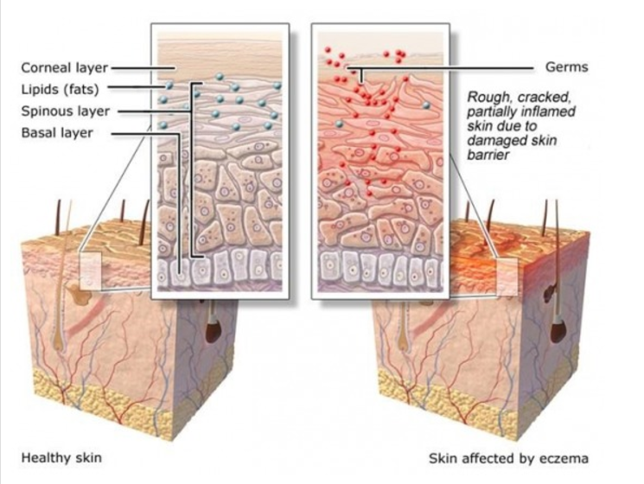

**Figure 1**: Side view of healthy skin (left) and skin effected by eczema (right)

**Mometasone Furoate:**

Mometasone Furoate is a form of corticosteroids that resemble cortisol, a hormone produced naturally by the adrenal gland (Barnes, 2005). Mometasone Furoate works by binding to liganded glucosteroid receptors, reducing the activity of the immune system which is causing the inflammation of the skin in Eczema patients, making it one of the most effective, widely used treatments of inflammatory diseases such as eczema (Barnes, 2005). Although corticosteroids provide many benefits, if used on large areas of the skin for prolonged duration, Mometasone Furoate can diffuse beyond the Dermis, entering into the bloodstream and causing systemic side effects such as osteoporosis or muscle weakness. Considering that over 3 million people suffer from eczema and the widespread use of corticosteroids, this model is of interest for patients to ensure that their Mometasone Furoate usage does not reach levels that would lead to systemic effects.

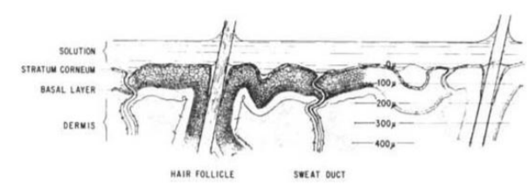

**Figure 2:** Side view of the different layers of the skin

**FINAL ITERATION**

**Assumption:**

1. Mometasone Furoate diffuses axially into the skin
2. The skin is modeled as having a slab geometry
3. Concentration of Mometasone Furoate on the surface of the skin decreases as a function of time
4. Mometasone Furoate concentration changes as a function of position in the skin as well as time
5. Mometasone Furoate is consumed by skin cells through an Michaelis-Menten enzymatic reaction
6. Diffusion coefficient changes as a function of position
7. Mometasone Furoate diffuses into the skin but does not exit the skin

**System Diagram:**

Stratum Corneum

Basal Layer

Dermis

**Figure 3:** A diagram of the system, showing the boundary with Mometasone Furoate crossing it

In this system, Mometasone Furoate diffuses axially into the skin through each of the different layers that each have a different diffusion coefficient.

**Parameters:**

* Diffusion Coefficient: The diffusion coefficient is a proportionality constant between the molar flux due to molecular diffusion and the gradient in the concentration of the species. Layers of the skin with less thickness have a larger diffusion coefficient
* Thickness of the skin: The thickness of the skin impacts the diffusion rate of Mometasone Furoate into the skin. The thicker the skin, the longer it takes for the particles to diffuse through
* Km values of Mometasone Furoate: Km is concentration of the substrate that allows the enzyme to reach half of Vmax. The larger Km is, the faster the rate of Mometasone Furoate consumption.

**Mass Balance:**

**Finite Difference Method:**

**Initial Condition**

**Boundary Condition**

**Final Plot of Change of Mometasone Furoate Concentration Change in the Skin**

**Figure 4:** Graph showing change of Mometasone Furoate concentration as x (position) increases for all times

**Nomenclature:**

|  |  |  |
| --- | --- | --- |
|  | Cross-sectional area of the skin | [m2] |
|  | Accumulation of MF in the skin | [-] |
|  | Concentration of MF in skin | [mol/m3] |
|  | Total consumption of MF in the system | [-] |
|  | Concentration of MF in dermis | [mol/mm3] |
|  | Diffusion coefficient of the skin | [mm2/hr] |
|  | Diffusion coefficient of MF in basal layer | [m2/s] |
|  | Diffusion coefficient of MF in dermis | [m2/s] |
|  | Diffusion coefficient of MF in the Stratum Corneum | [m2/s] |
|  | Diffusion coefficient of MF in skin | [m2/s] |
|  | Mass flux of MF entering skin | [mol/m2s] |
|  | Generation of MF in the skin | [-] |
|  | MF entering the Skin | [-] |
|  | Mometasone Furoate | [-] |
|  | Mass flow of MF in the skin layer | [mol/s] |
|  | Position point in reference to data | [-] |
|  | MF leaving the dermis | [-] |
|  | Time point in reference to data | [-] |
|  | Time | [s] |
|  | Step size for time | [hr] |
|  | Volume of the skin | [m3] |
|  | Position in dermis parallel to flow | [m] |
|  | Step size for position | [mm] |
|  |  |  | |
|  |  |  | |
|  |  |  | |
|  |  |  | |
|  |  |  | |
|  |  |  | |
|  |  |  |

**COMPUTATIONAL PROGRAM (EXCEL)**

First, the linear function for the diffusion coefficient was found by plotting the following data in excel:

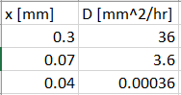

The following is the resulting plot of the data:

Next, the initial conditions and boundary conditions were entered into Excel:

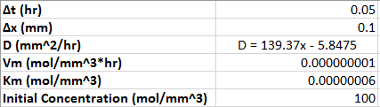

The values listed above can be easily changed in Excel to any desired input

The following equation was then entered into excel for m values of 0 through 0.4 mm and for p values of 0 through 1 hour.

For p: 0 through 0.4 hr

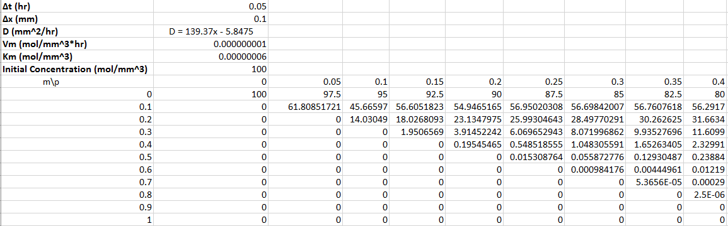

For p: 0.4 through 1 hr

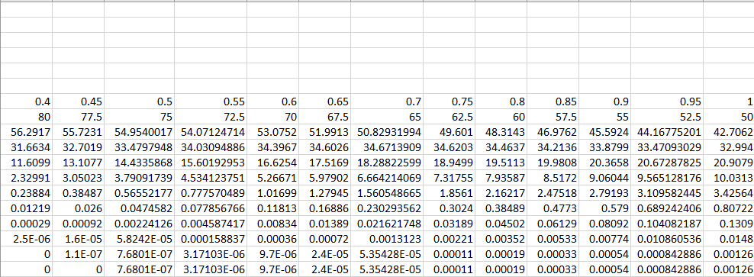

The following shows the actual input into each cell for concentration:

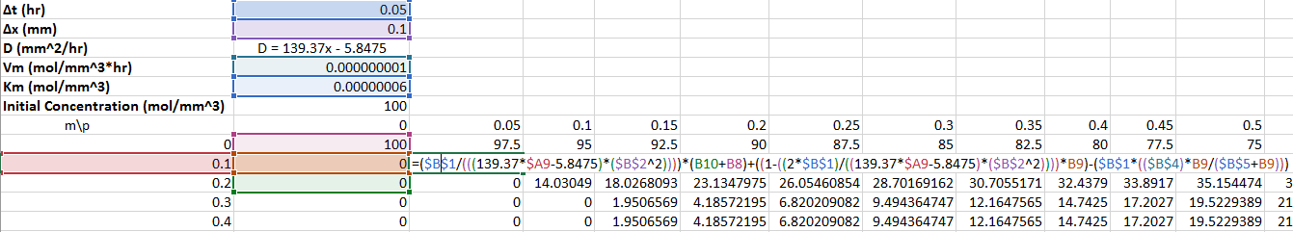

The following shows the actual input to find initial concentration at m = 0:

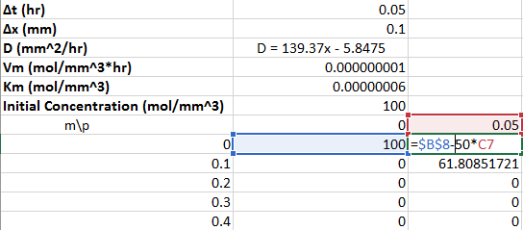

**MODEL ANALYSIS/FINAL CONCLUSION**

The final model developed using Finite differences method is a large improvement on the previous iterations and is able to model simple diffusion of Mometasone Furoate into the skin. In the first iteration, the diffusion of Mometasone Furoate into the skin treated the skin as a lumped parameter system, only dependent on time, not position. Since the system was initially treated as a lumped parameter, the diffusion coefficient, one of the most important parameters, was constant throughout the skin. The first iteration also kept a constant initial concentration of Mometasone Furoate applied to the surface of the skin, essentially saying that there was a never-ending supply of Mometasone Furoate applied to keep the concentration on the surface constant. Needless to say, the first few iterations required much improvement.

After several iterations, the final iteration of the model was able to improve on several of the shortcomings of the initial iterations. The first improvement was the model’s ability to model change of Mometasone Concentration diffusing into the skin as a function of both time and position through the use of forward finite difference methods. The model also considers that as the Mometasone Furoate diffuses through the skin, some of the Mometasone Furoate will be consumed by skin cells. The model output shown in Figure 4 showed that as time increases for each position, concentration increases until a certain point in time where concentration begins to fall. This agrees with the physical situation because the rate at which Mometasone Furoate diffuses into the skin increases until the initial concentration drops low enough that the concentration flux is overpowered by the consumption of Mometasone Furoate. The final iteration makes initial concentration a function of time, subtracting time multiplied by an arbitrary constant, in this case, 50, from the initial concentration at t = 0 hrs. Once again, looking at Figure 4, the model shows the concentration for all times decreasing drastically from position 0 mm to 0.1 mm which makes sense because the first layer the Mometasone Furoate must diffuse through is the Stratum Corneum which has a layer of dead skin cells as well as a lipid matrix, causing it to create the largest resistance for Mometasone Furoate to diffuse through. This would lead to a large decrease in concentration of Mometasone Furoate passing through this layer. A large improvement that this final iteration makes compared to the first few iterations is that it does not assume that the diffusion coefficient is constant for all the different layers of the skin. The model changes the diffusion coefficient as a function of position because each layer has drastically different thicknesses as well as different physical properties, causing the diffusion coefficient to not remain constant throughout the skin.

Ultimately, the model predicts that at an initial concentration of 100 mol/mm3 at time 0, the concentration of Mometasone Furoate at the dermis or position 0.4 mm is about 10.03 mol/mm3 after 1 hour and 1.01 mol/mm3 after 24 hours. Thinking about this output logically, this concentration is still way too high after an entire day. This is, however, much larger than that what would it would most likely be in the real physical situation. One of the major issues the model has is that it does not have an accurate way to model the decreasing concentration at position 0 mm across all times. The final iteration uses an arbitrary constant to decrease the concentration as a function of time but this is still just an estimate and not accurate at all. Additionally, the model assumes that the Mometasone Furoate is consumed through an enzymatic reaction and while this may be a good estimate, it may not completely model the actual mechanisms involved in the binding of Mometasone Furoate to the different receptor on the skin cells. The model makes a major assumption that the skin has uniform thickness which has a large impact on the diffusion of Mometasone Furoate. In the real physical situation, this is not the case. The values used for Vm and Km for Mometasone Furoate was unable to be found and therefore had to assumed based on the Vm and Km values of similar corticosteroids. This assumption has a large impact on modeling the consumption of Mometasone Furoate.

Due to a lack of information, the model has several limitations during its implementation. Pore size and the number of pores on the surface of the skin plays a large role in changing the rate of diffusion into the skin, however, this was not incorporated into the model. Another limitation is the inability to take the into account the loss of Mometasone Furoate during its application to the surface of the skin where it is rubbed in. The model is limited in its ability to take into account the rheological properties of Mometasone Furoate cream in its flow into the skin. The model was created using forward finite differences, making it susceptible to major fluctuations depending on the different time and position step sizes. This along with the format of Excel spreadsheets can often limit the ease of use for the user. This model is still currently a rough approximation of Mometasone Furoate diffusion into the skin and hopefully with further iterations and a better understanding of different fundamental principles, the model can be improved.

**APPENDIX**

**ITERATION 1**

**System Diagram:**

Mometasone Furoate

Δz

Δy

Skin

Mometasone Furoate

Δx

Skin

x

z

Mometasone Furoate

y

**Assumptions:**

1. The MF cream is a metabolically stable, fluid comprised of only MF
2. The MF cream has uniform concentration throughout
3. The skin only contains one solid layer
4. Closed system with respect to skin layer
5. Skin is completely homogenous
6. Only diffusive flow, no bulk flow/convection
7. No chemical reactions occur within the dermis with the MF
8. Skin has a flat plate or slab geometry
9. Skin has constant thickness and diffusivity throughout
10. Nothing flows out of the skin

**Computations:**

MASS BALANCE

**Nomenclature:**

|  |  |  |
| --- | --- | --- |
|  | Cross-sectional area of the skin | [m2] |
|  | Accumulation of MF in the skin | [-] |
|  | Concentration of MF in skin | [mol/m3] |
|  | Total consumption of MF in the system | [-] |
|  | Diffusion coefficient of MF in skin | [m2/s] |
|  | Mass flux of MF entering skin | [mol/m2s] |
|  | Generation of MF in the skin | [-] |
|  | MF entering the Skin | [-] |
|  | Mometasone Furoate | [-] |
|  | Mass flow of MF in the skin layer | [mol/s] |
|  | MF leaving the dermis | [-] |
|  | Time | [s] |
|  | Volume of the skin | [m3] |
|  | Position in dermis parallel to flow | [m] |
|  |  |  |

**Issues and Future Improvements:**

This first iteration ends up with an overall differential equation for change in concentration of Mometasone Furoate in the skin layer with respect to time. This first iteration is primarily a mass balance setup of the system. However, this initial model is very flawed, mainly due to the assumptions made. The skin is comprised of many different layers so assuming only one layer is flawed. Additionally, the model assumes that none of the Mometasone Furoate is consumed. We know that this is not true because a portion of MF binds to receptors in skin cells in order to block it from producing inflammation-inducing chemicals such as prostaglandins. Additionally, the current model is not necessarily solvable with the second order differential equation on the other side of the equation and the lack of boundary conditions.

**ITERATION 2**

**System Diagram:**

Mometasone Furoate

Epidermis

Dermis

**Changed Assumptions:**

1. The skin only contains 2 layers, the epidermis and dermis with different thicknesses
2. Both layers of the skin are completely homogenous
3. The layers of the skin are connected with no gap between them

**Computations:**

We only care about the concentration of MF, not water

**Nomenclature:**

|  |  |  |
| --- | --- | --- |
|  | Concentration of MF in skin | [mol/m3] |
|  | Concentration of MF at surface of epidermis | [mol/m3] |
|  | Concentration of MF in skin Concentration of MF at exit point of skin | [mol/m3] |
|  | Diffusion coefficient of MF cream in skin | [m2/s] |
|  | Diffusion coefficient of MF in dermis | [m2/s] |
|  | Diffusion coefficient of MF in epidermis | [m2/s] |
|  | Mass flux of MF in skin | [mol/m2s] |
|  | Length of dermis | [m] |
|  | Length of epidermis | [m] |
|  | Mometasone Furoate | [-] |
|  | Time | [s] |
|  | Position in dermis parallel to flow | [m] |
|  |  |  |

**Issues and Future Improvements:**

In this iteration, the second order differential is broken down a bit to make it a little easier to manipulate and solve. Additionally, this iteration takes into account that the skin has more than just one layer. Also, the iteration takes into account that the layers of the skin have different thicknesses as well as different diffusivity of MF in the layers. This model is still flawed however, since the skin has more than two layers and the layers are not uniform solids. The layers have different components depending on position in it such as a lipid layer that may cause additional loss of MF. At this point in time, there is still no numerical solution because we do not have the skills to solve the ODE that is dependent on both time and position.

**ITERATION 3**

**System Diagram:**

Mometasone Furoate

Stratum Corneum

Basal Layer

Dermis

**Changed Assumptions:**

1. The skin only contains 3 layers, the stratum Corneum, basal layer, and dermis with different thicknesses
2. All layers of the skin are completely homogenous

**Computations:**

**Nomenclature:**

|  |  |  |
| --- | --- | --- |
|  | Concentration of MF in skin | [mol/m3] |
|  | Concentration of MF at surface of epidermis | [mol/m3] |
|  | Concentration of MF in skin Concentration of MF at exit point of skin | [mol/m3] |
|  | Diffusion coefficient of MF in basal layer | [m2/s] |
|  | Diffusion coefficient of MF in dermis | [m2/s] |
|  | Diffusion coefficient of MF in the Stratum Corneum | [m2/s] |
|  | Length of basal layer | [m] |
|  | Length of dermis | [m] |
|  | Length of the Stratum Corneum | [m] |
|  | Mometasone Furoate | [-] |
|  | Time | [s] |
|  | Position in dermis parallel to flow | [m] |

**Issues and Future Improvements:**

This iteration takes into account that there are more than 2 layers of the skin and each layer has a different thickness and diffusion coefficient. However, again this model is still lacking since the model does not take into account consumption of the MF as it passes through the skin. Once again, it is still not possible to solve this ODE so therefore, in next iteration, the system will be treated as a lumped parameter system.

**ITERATION 4**

**Changed Assumptions:**

* Dermis is a lumped parameter system, changes in MF concentration only with time
* MF is consumed by different cells as it passes through the layers
* MF consumption is a first order reaction
* 1-D diffusion of MF into the dermis layer
* The stratum Corneum and basal layer have different diffusion coefficients
* Loss of MF cream to air is negligible

**System Diagram:**

Mometasone Furoate Application Layer

Stratum Corneum

Basal Layer

Dermis

**Computations:**

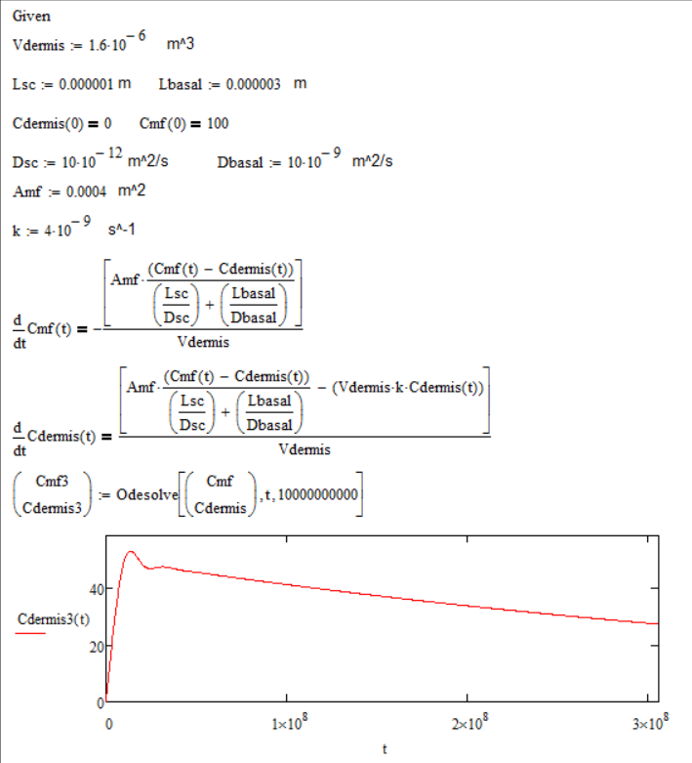

**Nomenclature:**

|  |  |  |
| --- | --- | --- |
|  | Area covered by the MF applied to the surface of the skin | [m2] |
|  | Concentration of MF in the dermis | [mol/m3] |
|  | Concentration of MF on the skin | [mol/m3] |
|  | Diffusion coefficient of MF in basal layer | [m2/s] |
|  | Diffusion coefficient of MF in dermis | [m2/s] |
|  | Diffusion coefficient of MF in the Stratum Corneum | [m2/s] |
|  | First order reaction rate constant | [s-1] |
|  | Length of basal layer | [m] |
|  | Length of the Stratum Corneum | [m] |
|  | Mometasone Furoate | [-] |
|  | Volume of the dermis | [m3] |
|  | Time | [s] |
|  | Position in dermis parallel to flow | [m] |

**Issues and Future Improvements:**

The current model is able to show change of concentration of MF in the dermis as a function of time. However, the major issue here is that it only changes with time, not with both time and distance which is how it would be in a real physical situation. This will have to be improved later on using finite difference. Additionally, currently the maximum concentration in the dermis is quite large and takes a long time for it to drop to 0. This is not the case in a physical situation because unfortunately, the majority of the MF does not typically make it into the dermis layer according to literature. Therefore, to improve upon this, a different reaction will have to be used to model MF consumption

**ITERATION 5**

**Changed Assumptions:**

* MF consumption is an enzymatic reaction

**Computations:**

Mathcad Program:

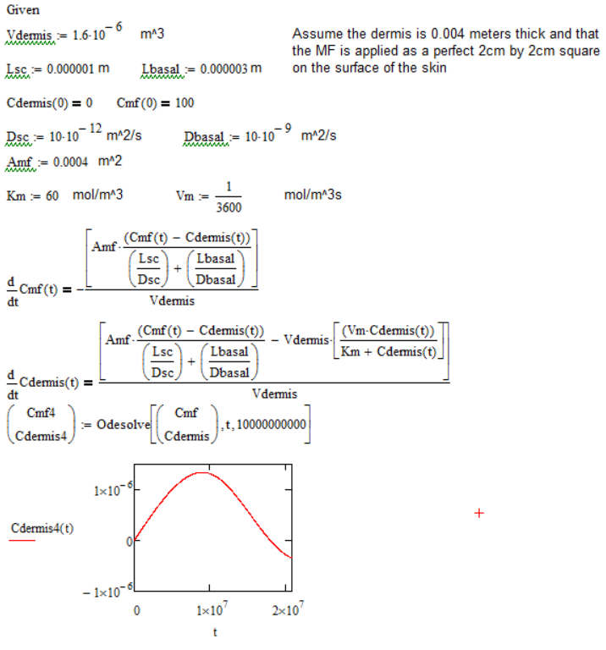

**Nomenclature:**

|  |  |  |
| --- | --- | --- |
|  | Area covered by the MF applied to the surface of the skin | [m2] |
|  | Concentration of MF in the dermis | [mol/m3] |
|  | Concentration of MF on the skin | [mol/m3] |
|  | Diffusion coefficient of MF in basal layer | [m2/s] |
|  | Diffusion coefficient of MF in dermis | [m2/s] |
|  | Diffusion coefficient of MF in the Stratum Corneum | [m2/s] |
|  | Dissociation constant of the MF and enzyme complex | [mol/m3] |
|  | Length of basal layer | [m] |
|  | Length of the Stratum Corneum | [m] |
|  | Mometasone Furoate | [-] |
|  | Volume of the dermis | [m3] |
|  | Maximum velocity of the MF consumption reaction | [mol/m3s] |
|  | Time | [s] |
|  | Position in dermis parallel to flow | [m] |

**Issues and Future Improvements:**

Currently, this model, like the previous iteration, only accounts for changes in concentration of MF in the dermis as a function of time and not position. Therefore, in the next model, finite differences will be attempted and hopefully a more realistic model can be created. Overall, this model should potentially be a better model than the previous iteration because an enzymatic reaction for MF consumption was used which according to literature, is a more realistic way to model hormone consumption. However, it can be seen in the graph above that concentration of MF in the dermis drops below 0 which is impossible so most likely, this is due to the values used for some of the constants. Further research will need to be done to improve those values.

**ITERATION 6**

**Assumptions:**

* Concentration changes as a function of time and distance
* No MF is consumed while passing through the different layers (taking a step back just to make sure focus is on performing finite differences correctly)

**Computations:**

**Initial Condition**

**Boundary Condition**

Excel Finite Differences Program:

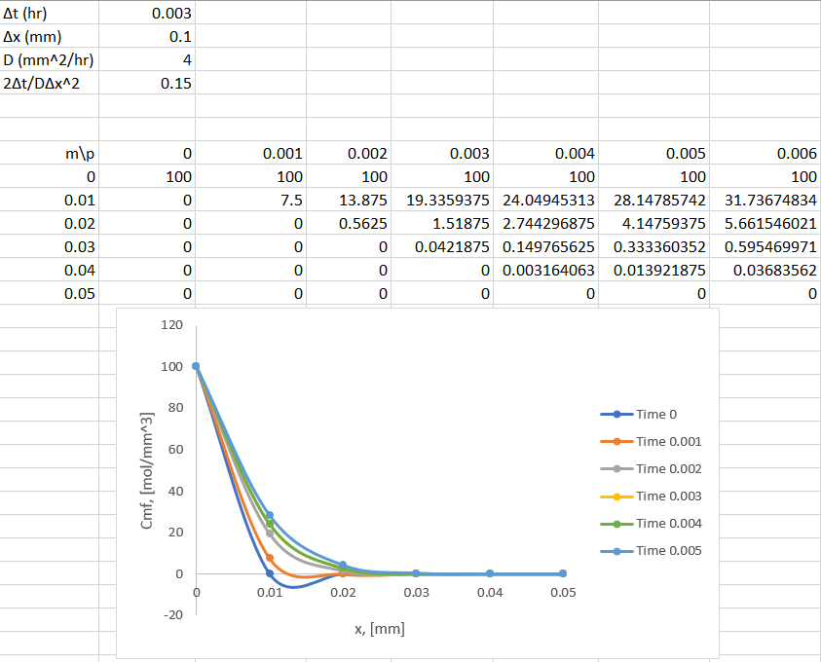

**Nomenclature:**

|  |  |  |
| --- | --- | --- |
|  | Concentration of MF in dermis | [mol/mm3] |
|  | Diffusion coefficient of the skin | [mm2/hr] |
|  | Position point in reference to data | [-] |
|  | Time point in reference to data | [-] |
|  | Step size for time | [hr] |
|  | Step size for position | [mm] |

**Issues and Future Improvements:**

In this model, concentration of MF in the dermis changes with time and position as seen in the graph above. The graph makes sense because increasing series number represents increases time and at the earliest time, concentration is lower with changing position when compared to later time points. Even though this model is improved from the previous iteration in the fact that it now takes position into account, however, in this iteration, we once again assumed that the diffusion constant is constant throughout all the layers which is not true in the physical situation. Additionally, this model is lacking the consumption of MF as it passes through the skin. In the next iteration, diffusion constant will need to be made into a function that changes with position.

**ITERATION 7**

**Changed Assumptions:**

* Diffusion coefficient can be modeled as a second order function with respect to position

**Computations:**

The following values for diffusion coefficient were retrieved from literature (Davey, 2011)

The different diffusion coefficients were fitted with a 2nd order polynomial to create a diffusion coefficient function for predicting the diffusion coefficient at each position.

Excel Finite Differences Program:

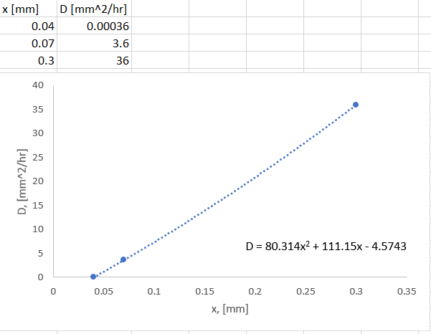

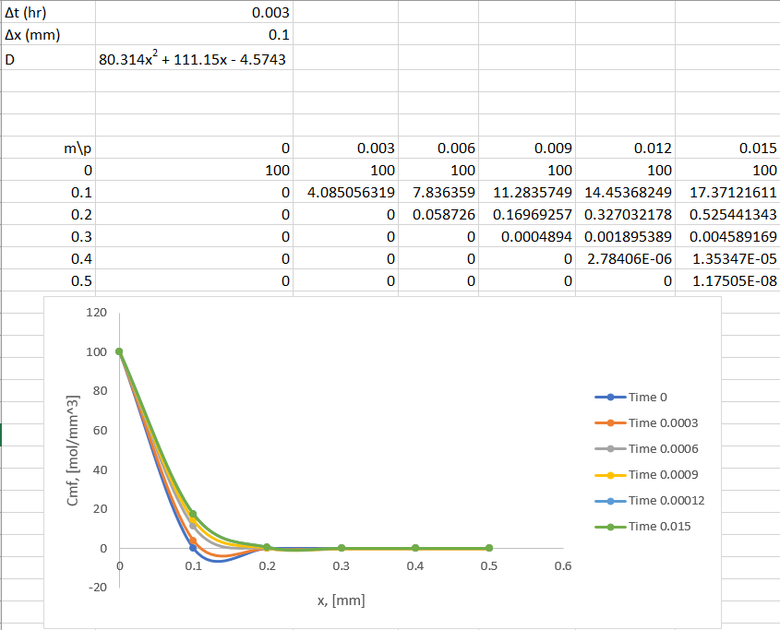

**Nomenclature:**

|  |  |  |
| --- | --- | --- |
|  | Concentration of MF in dermis | [mol/mm3] |
|  | Diffusion coefficient of the skin | [mm2/hr] |
|  | Position point in reference to data | [-] |
|  | Time point in reference to data | [-] |
|  | Step size for time | [hr] |
|  | Step size for position | [mm] |

**Issues and Further Improvements:**

In this iteration, we account for the fact that the diffusion constant is not constant for all the different layers of the skin. Looking at the different diffusion constants for each layer, it made sense that the diffusion constant does not change with position linearly, but most likely by some higher order equation. The graph above shows diffusion constant changing with respect to position as a second order polynomial. Overall, the graph looks relatively the same as the previous iteration where the diffusion constant was help constant. The concentrations also seem to drop close to zero sooner than in the previous iteration. To improve on this model in the next iteration, the diffusion constant will be fitted with a cubic spline. Additionally, the consumption term will be added back in.

**LITERATURE CITED**

Barnes, P. J. (2006). How corticosteroids control inflammation: Quintiles Prize Lecture 2005. British Journal of Pharmacology, 148(3), 245–254. http://doi.org/10.1038/sj.bjp.0706736

Davey, S., & Patel, N. (2011). Diffusion Across the Skin: Diffusion of Lidocaine. Retrieved April 29, 2017, from http://isn.ucsd.edu/classes/beng221/problems/2011/project03.pdf

Eczema: Overview. (2017, February 23). Retrieved April 29, 2017, from https://www.ncbi.nlm.nih.gov/pubmedhealth/PMH0072583/#i2257.sources